Installation Manual for Ble Nano

1.Necesary components
- Smartphone with android operating system and bluetooth 4.0
- An account for online compiler https://developer.mbed.org/handbook/mbed-Compiler
- Ble Controller app for android to establish communication with the bluetooth module
- nRF toolbox app for android to upload the hex file for Ble Controller
2.Online Compiler
The online compiler can create two types of files:
- hex files with bootloader
- hex files for FOTA(firmware on the air) protocol

To generate the hex files first the online compiler must know the type of the controller so first step is to add the board from section Hardware->Boards->RedBearLab Ble Nano

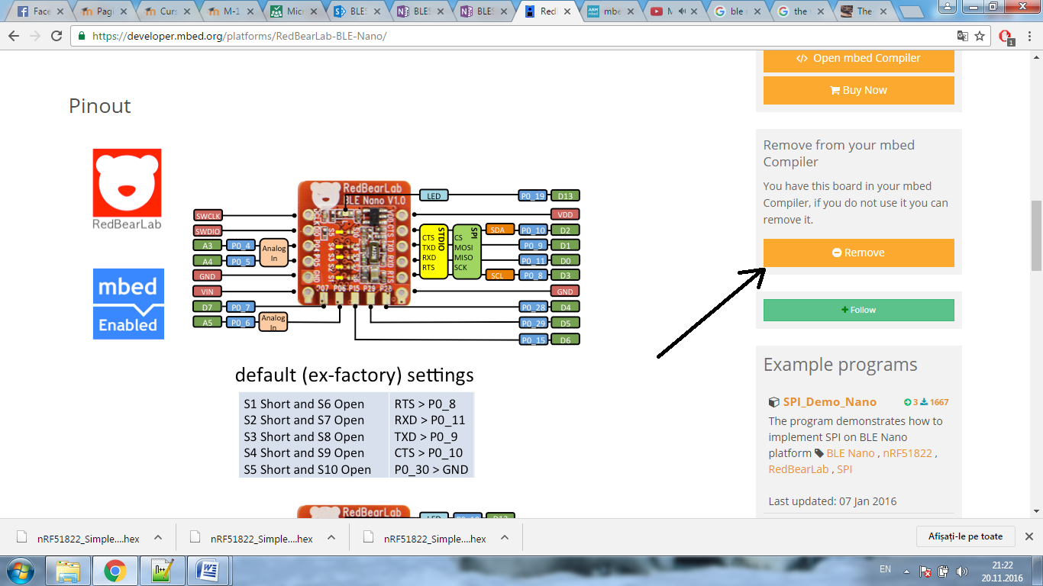

In this case the board was already added so just the remove option remain.
After the code was compiled the browser will automatically download the hex file.

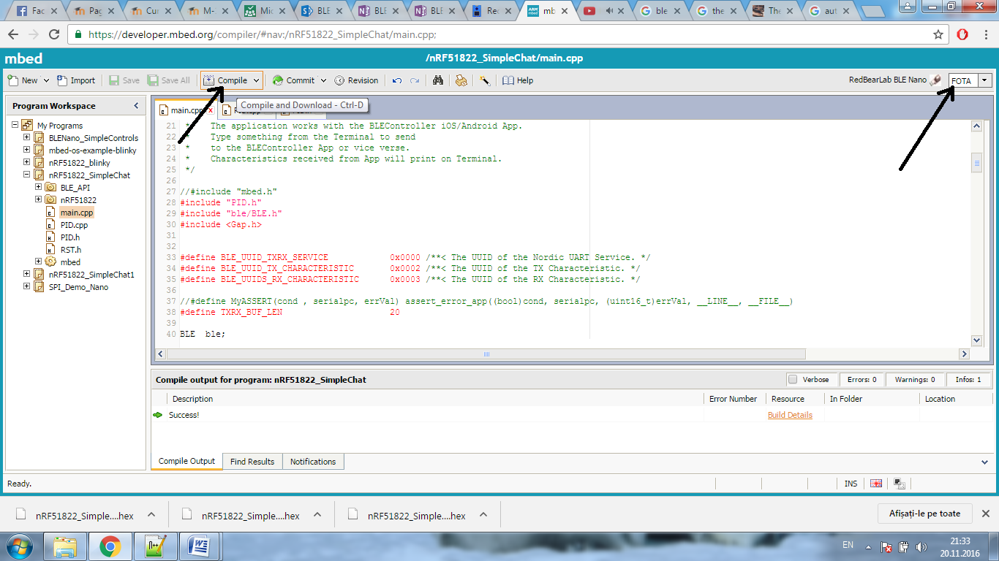

3.Types of files
To transfer with bluetooth the hex file, the nRF Toolbox app must ne started and the option default DFU must be selected. The app will ask what type of file will be uploaded and four option will be displayed.
- Distribution packet(ZIP)
- Soft Device
- Bootloader
- Application
For this project just the last two types of files are relevant.

4.Bootloader files
This step must be completed just if the Ble Controller was never programmed with an app which contains a bootloader file. In this case the only option to upload the code is with the USB from the PC. The app which contain the bootloader is too big to be transmitted with nRF toolbox app.
5.Apps without bootloader
In this case the file can be transmitted via bluetooth, if the hex file was generated with the online compiler for FOTA protocol. The second step si to use the nRF toolbox with the default option to upload the hex file. For final step the Ble Controller app for android is used to receive or to transmit data with the board.

